**NAGARJUNA COLLEGE OF INFORMATION TECHNOLOGY**

**TRIBHUVAN UNIVERSITY**

**INSTITUTE OF SCIENCE AND TECHNOLOGY**

A Project Report on

**“Online Examination System”**

**‘Using Fisher Yates Shuffle and Tokenization Algorithm’**

Submitted To:

Department of Computer Science and Information Technology

Nagarjuna College of Information Technology

*In partial fulfillment of the requirements for the bachelor’s Degree in*

*Computer Science and Information Technology*

Submitted By:

Bishworaj Ghimire, 3269/070

Nischal Ghimire, 3278/070

Shyam Bakhrel, 3289/070

Sudip Maharjan, 3292/070

Date: 2074/04/12

# Acknowledgement

This project report on “Online Examination Management System” has been prepared as a partial fulfillment for the seventh semester of Bachelor of Science in Computer Science and Information Technology. As we all know that gratitude cannot be express in any paper or written form. But we have to thank some people who have helps us for the project to take its shape.

At first we would like to thank my honorable supervisor **Mr. Ramesh Singh Saud** for sharing his knowledge with us and giving us his time. We like to thanks **Mr. Jaya Mangal Gupta**, Director of Nagarjuna College of IT for giving me this opportunity to undertake this project.

We would like to thank rest of the faculty members of Department of Computer Science and Information Technology for their constant support and guidance during our academic career, hence enabling us to build strong foundation for our professional career. We would also like to thank all non-teaching staff and computer lab staff for their assistance and support.

# Abstract

The project as by the name ‘Online Examination System’ using Fisher Yates Shuffle and Tokenization algorithm is web application which is based on entrance exams of various educational subjects. This application is made after studying the current similar applications and systems in Nepal. The motive of making this project is to make the students involve in online exam practice for preparation of various exams like MBBS entrance exam, engineering entrance exam, BSc CSIT entrance exam and so on. The application uses fisher yates algorithm for the purpose of shuffling the questions which appear during exam. This make no repetition of the same questions while students take the exam. Another algorithm used is tokenization, for the purpose of validating the word answers given by students.

# Letter of Approval

This is to certify that this project prepared Bishworaj Ghimire, Nischal Ghimire, Shyam Bakhrel and Sudip Maharjan entitled "Online Examination System" in partial fulfillment of the requirements for the degree of B.Sc. in Computer Science and Information Technology has been well studied. In our opinion, it is satisfactory in the scope and quality as a project for the required degree.

…………………..

Ramesh Singh Saud

(Supervisor)

………………….

External Examiner

Tribhuvan University, CSIT

**TABLE OF CONTENTS**

Acknowledgement i

Abstract ii

Letter of Approval iii

List of Figures vii

List of Tables viii

Chapter 1: Introduction 9

1.1. Background Study 9

1.2. Problem Statement 9

1.3. Objectives of Study 10

1.4. Scope and Limitations 11

1.4.1. Scope 11

1.4.2 Limitations 11

Chapter 2: Literature Review 12

2.1 Study of existing system 12

2.2. Algorithms Used 12

2.2.1. Fisher-Yates Shuffling Algorithm 12

2.2.2. Tokenizationand stemming 13

Chapter 3: Requirement Analysis and Feasibility Study 15

3.1. Planning 15

3.2. Requirement Analysis 15

3.2.1. Functional Requirements 15

3.2.2. Software Requirements 18

3.3. Feasibility Study 19

3.3.1. Technical Feasibility 19

3.3.2. Economical Feasibility 19

3.3.3. Operational Feasibility 20

3.4. Project Management 20

3.4.2. Issue Resolution 21

3.5. System Analysis 21

Chapter 4: System Design 23

4.1. Conceptual Idea 23

4.1.1. System Flow Chart 23

4.1.2. Activity Diagram 25

4.1.3. Entity Relationship Schema Diagram 26

4.2. The Unified Modeling 27

4.2.1. Sequence diagram 27

4.2.2. Class Diagram 28

Chapter 5: System development, Implementation and Testing 30

5.1. Programming Review 30

5.1.1. Front End 30

5.1.2. Back End 30

5.1.3. Documentation tools 30

5.1.4. Designing 31

5.1.5. Coding tools 31

5.2. Algorithm Implementation 31

5.2.1. Fisher Yates Algorithm 31

5.2.2. Tokenization Algorithm 32

5.3. Testing 33

5.3.1. Unit Testing 33

5.3.2. Integration Testing 35

5.3.3. System Testing 37

5.4. Module Description 37

5.4.1. User Interface Module 37

5.4.2. Database Operations Module 39

Chapter 6: Conclusion and Future Enhancements 40

6.1 Conclusion 40

6.2 Future Enhancement 40

References 41

# List of Figures

Fig 3.1 Use case Diagram of Online Examination System……………………...……………………15

Fig 4.1: System Architecture and Overview…………………………………………………………..21

Fig 4.2: Activity Diagram of the System………………………………………………...…………….23

Fig 4.3: Entity Relationship Diagram of the System……………………………………………….…………..24

Fig 4.4: Sequence Diagram of the System…………………………………………………..………...25

Fig 4.5: Class Diagram of the System………………………………………………….……………...26

Fig 5.2 (a) - Integration Testing (User Login)…………………………………………………………33

Fig 5.2 (b) - Integration Testing (Question Record Update)…………………………………………..34

Fig 5.2 (c) - Integration Testing (Question Generation and Answer Validation) ……………………..34

# List of Tables

Table 5.1: Unit Testing……………………………………………………………………………….32

Table 5.1(a): Admin Module…………………………………………………………………………36

Table 5.1(b): Client Module………………………………………………………………………….37

# Chapter 1: Introduction

## 1.1. Background Study

The Online Examination Management System (OEMS) is a web application. This system will help the examinees to practice the exam system in terms of users that are registered in the system. This Online Examination Management System enables the users to create their own login. Then users can login with their unique login id and undertake the test available for an individual. The user can practice the online examination and report the outcome in a couple of time. Then the system generates the results with the help of the right answers in database. Users can give the online exam in term of Multiple Choice Questions (MCQ) where random number of question is generated by the system. This system generates random number and uses Fisher-Yates algorithm for the random question generation. For short answers, we use tokenization and Stemming techniques for answer validation. They can analyze their own performance level which helps them to improve in their academics.

Today Online Examination System has become a fast growing examination method because of its speed and accuracy. It is also needed less manpower to execute the examination. Almost all organizations nowadays, are conducting their objective exams online. It saves students time in examinations. Organizations can also easily check the performance of the student that they give in an examination. As a result of this, organizations are releasing results in less time. Mass quantities of papers are used for the purpose of examination. Implementing this system for purpose of examination, it can save lots of trees.

## 1.2. Problem Statement

In Nepal we lack single platform to learn or attend online exams for many fields such as MBBS entrance exams, Engineering entrance, BSc CSIT entrance exams and other educational examinations. This has led to problems for students to learn about such exam formats and question types.

Students can’t evaluate their skill set and knowledge properly by solving questions manually. Students are also unable to practice for such examinations online. Though there are some applications that may intend to solve such problems they are totally intended to single-problems solutions so student can’t learn and practice for multiple subjects. The existing examination system has many disadvantages such as it takes more time, involves the maintenance of paper, production and recycling of tons of paper and requires man power. Also it takes more time to get the results.

The main issue for developing the online examination systems is generating random questions without repetition. The questions generated for a user session should not be repeated again for the same session. The system should be able to maintain the time constraints for solving questions too. The system should accept short answer questions also. For which tokenization of phrases and stemming process to normalize the tokens are necessary.

## 1.3. Objectives of Study

The main objectives of our system are as follows:

* Allow students to take examination online via internet.
* To provide facility to students to submit online examination form and generate the exam roll no.
* To generate the student’s exam results.
* Generate the students’ progress in regular examinations through ranking system.
* Real time availability and user friendly.
* Reduce the hectic job of checking student’s answers manually.
* Time saving and more accurate examination system.

## 1.4. Scope and Limitations

### 1.4.1. Scope

Scope of this application is to conduct online examinations is proficient and efficient manner. This can be used in educational institutions as well as in corporate world. Also, students can save their most of the time by attending exams via internet facilitated locations. The examination conductors can also benefit from doing less hectic job of conducting examinations procedures such as managing seat plans, checking students answer sheet one by one manually. There is no restriction that examiner has to be present when the candidate takes the test. The checking and publishing results will be accurate and faster as the answers are crossed checked with the answers stored. The different examinations can be blended as the system provides adding subjects and manipulating type and number of questions.

### 1.4.2 Limitations of Study

Limitations are the certain criteria’s that may not be fulfilled by our application. Some of such limitations of our project are mentioned below:

* Internet access is mandatory. No individual can access our system services without Internet service.
* An online exam system is a little bit more susceptible for fraud.
* Highly dependent on honor system; hard to catch cheating. A group of students can take turns taking test first to share answers with others in the group raising their overall grade.

# Chapter 2: Literature Review

## 2.1 Study of existing system

There are few android based applications and few web applications for online examination. There are some applications with very good performance. Some applications also lacked random questions generating algorithms. Some of the applications lacked updates and timely maintenance. But most of these do not provide definite format for the examinations. Those applications lack proper marking and evaluation system. Most of the system uses good randomized question generating algorithms.

Some of the existing system that has been used for online examinationsare Meroanswer.com, gk.nepalwebtech.com, quizup etc. These systems keep track of questions, user level and are equipped with good setting of timing constraints, but most of the system only supported multiple choice answers. On research, we have found out that very few system supported answer in words or phrase. No, systems were found to be using Porter Stemmer for stemming purpose.

## 2.2 Planning

In planning phase a study on required data is done. This system is data based so collection of reliable data and finer pre-processing of that data is our main objective. We also need huge amount of data. We concluded that there is no better alternative than internet for data collection.

The collected data (questions and answers) are the major parts of our application. On the basis of collected data, here we are trying to find out the best design concepts for destroyed heritage by the concept of distributed problem solving technique known as crowdsourcing. So, by using the Fisher Yates and Stemer Algorithm, we are going to develop application on PHP.

## 2.3 Requirement Analysis

The requirements are to be collected before starting of the projects’ development life cycle. The initial requirements are the one that head start the projects development.

### 2.2.1. Functional Requirements

By conducting the requirements analysis we listed out the requirements that are useful to restate the problem definition.

* **Administrator Aspect**
  1. Taking back up of the database.
  2. Editing/Deleting/Creating the records.
  3. Adding faculty or subject.
* **System Aspect**
  1. Logging into the system.
  2. Accepting registrations of students.
  3. Adding/editing/deleting the questions.
  4. Adding the student to a group.
  5. Creating questions and Posting questions.
  6. Posting multiple options to respective question.
  7. Marking correct answer within the given options and sending result to specific student.
  8. Time limit of the questions if any.
  9. Tokenization and Stemming of user answers for validation purpose.
  10. Generate marks after user submits answers.
* **Student Aspect:**
  1. Requesting registration.
  2. Logging into the system.
  3. Selecting the questions.
  4. Appearing for the examination.
  5. Reviewing the given responses.
* **Analysis**
  1. Authenticating users based on username and password
  2. Recording candidates’ responses to every question.
  3. Checking whether the given response is correct or not.
  4. The reports are required to be sent to the candidates.
  5. Invitations/report for the appearance for the new test will be posted.

**Use Case Diagram:**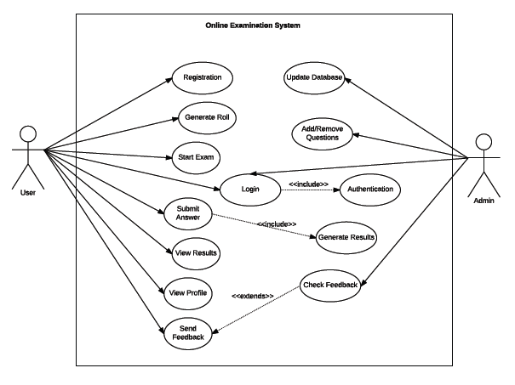

**1**Fig 3.1 Use case Diagram of Online Examination System

The above use case diagram shows the relationship between entities user (student), admin and the system.

### 3.2.2 Non Functional Requirements

It includes features such as:

**Performance:**

* After completing the exam, the entire score of the student will be calculated.
* The software shall support use of multiple users at a time.

**Usability:**

* The website should be user friendly and should require least effort to operate.

**Portability:**

* The website is made using HTML, CSS, PHP, etc. which are platform independent and can be transported to other servers with minimum effort.

**Availability:**

* Students can take exam only during the previously allotted time slots, however can open site anytime to access other information.
* This system must run on multiple operating systems and support windows operating system.

### 3.2.2. Software Requirements

Operating System: Windows

Database: MySQL

IDE/Workbench: Sublime Text

Server: XAMPP

**3.2.4. Technical Specifications**

* MySQL (SQL)
* XAMP for local hosting
* Sublime Text
* Adobe Photoshop CC for graphics design

## 3.3. Feasibility Study

A feasibility study is an analysis of how successfully a project can be completed, accounting for factors that affect it such as economic, technological, legal and scheduling factors. The feasibility study concluded that the project would be able to be implemented to success as it was carefully planned.  
Following things are taken under consideration under feasibility study:-

### 3.3.1. Technical Feasibility

Assessing technical feasibility is to evaluate whether the new system will perform adequately and whether an organization has ability to construct a proposed system or not. PHP is selected as a working platform, numbers of programmers are introduced to it, and so anyone familiar can go through the system. Now a day’s people are more familiar to use internet, this system keeps internet as a key to access it. General conventions used to build system as an effective one in this sector. A normal user can easily interact with User Interface through this system and explore for the needs.

### 3.3.2. Economical Feasibility

Determines whether the system is cost effective or not. All the cost of the new system compared with the benefits, which can be obtained for management approval. The benefit may be quantities in nature Current System Summary. The genuine consideration of the system being developed is the approach we follow to look the system in the way it is useful for us. Cost associated with the development of computer-based systems is as follows.

* Procurement costs such as consultation, equipment purchase, installation, furnishing the size etc.
* Start-up costs, user operating system cost, personal search cost etc. Project related costs such as software purchase, training personnel, data collection, documents preparation costs etc.
* Ongoing costs such as hardware, software maintenance, rental, depreciation of hardware costs etc. Easy installation and free of cost in use.

### 3.3.3. Operational Feasibility

This system can be operated through any web browser. Not only the computer systems but also other devices like Personal Digital Assistant devices, mobile devices with internet services or with mobile networks. This system doesn’t use any additional resources beyond the systems inbuilt and an Internet connection to log in.

## 3.4. Project Management

**Project management** is the application of knowledge, skills, tools, and techniques to project activities to meet the project requirements. Project managementis the discipline of initiating, planning, executing, controlling, and closing the work of a team to achieve specific goals and meet specific success criteria. Aprojectis a temporary endeavor designed to produce a unique product, service or result with a defined beginning and end (usually time-constrained, and often constrained by funding ordeliverables) undertaken to meet unique goals and objectives, typically to bring about beneficial change or added value.The temporary nature of projects stands in contrast withbusiness as usual (or operations), which are repetitive, permanent, or semi-permanent functional activities to produce products or services. In practice, themanagementof these two systems is often quite different, and as such requires the development of distinct technical skills and management strategies. The primary challenge of project management is to achieve all of the project goals and constraintsthis information are usually described in a user or project manual, which is created at the beginning of the development, the primary constraints of many things.The secondary and more ambitious challenge is tooptimizetheallocationof necessary inputs and integrate them to meet pre-defined objectives.

**3.4.1. Project Work Flow and Schedule**

* Team Size: 4
* Total Effective Project Duration : 16 weeks
* Effort Required Per Person: 2-3 Hours Per Day

### 3.4.2. Issue Resolution

Projects are initiated to find a solution for an issue. The best project know how to assign an ownership of an issue to a project team, to analyze smartly on problem-solving, decision making, planning method and then move to resolution.

Responsibilities of Supervisor:

* Schedule the project
* Schedule Tracking
* Code Debugging
* Share information

Responsibilities of Team Members:

* Research about the project
* Analyze and design
* Development and testing
* System Installation and Implementation
* Project Documentation and Report Submission

## 3.5. System Analysis

It is the process of studying a procedure or business in order to identify its goals and purposes and create systemsand procedures that will achieve them in an efficient way. System analysis is a detailed study of various operations performed by a system. That is a structural process related to four significant phases. They are study phase, design phase, development phase and implementation phase. A good analysis is essential for the development of a new improved system.

There are various frameworks available for web application development. The proposed system is supposed to work across various platforms and development environment should be able to run such that the developers need not go through difficult configuration procedure.

Web applications are computer programs allowing website visitors to submit and retrieve data to/from a database over the Internet using their preferred web browser. The significant advantage of building and maintaining web applications is that they perform their function irrespective of the operating system and browsers running client side. Web applications are quickly deployed anywhere at no cost and without any installation requirements (almost) at the user’s end.

# Chapter 4: System Design

In system design phase, we define the architecture, components, modules, interfaces, and data for the system to satisfy specified requirements. Systems design could be seen as the application of systems theory to product development.

## 4.1. Conceptual Idea

The system that has been developed here is a web-based platform. So, basically it maintains information about users (students), questions and answers of different subjects, their results and designs. It is required for the system to provide a Main Page where any user (any user who has access to internet) will be able to access. A person who wants to give examinations on various subjects can register himself online using this system in the same fashion like he does it in web application.

### 4.1.1. System Flow Chart

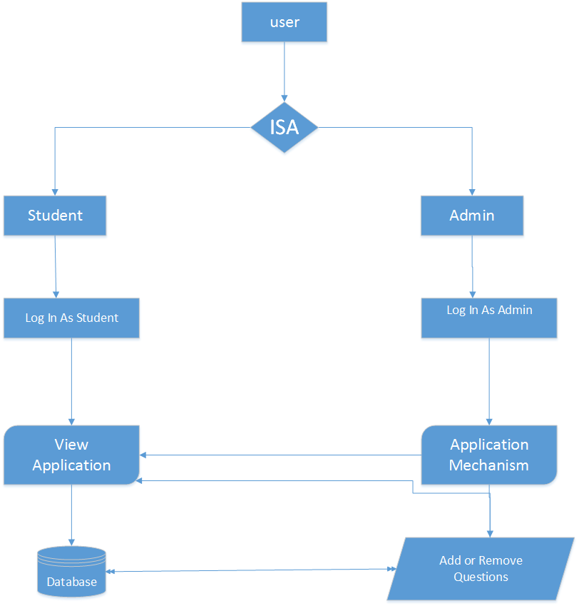

Fig 4.1: System Architecture and Overview

Flowcharts depict the sequence in which processes execute or take place. The sequence of execution of a user, admin and database are shown in the following flowcharts. The following flowchart shows the basic steps of operation in the system.

The above Flow Chart describes the whole operation of the final system. The users are always registered ones where they are allowed to view the information and designs posted by the admin or system. Both users and admin have to go through login process to view or work on application. And the registered users can take the examinations. The admin can add, delete or update questions and their answer.

### 4.1.2. Activity Diagram

The below is an activity diagram of the system that shows the flow of system through different phases.

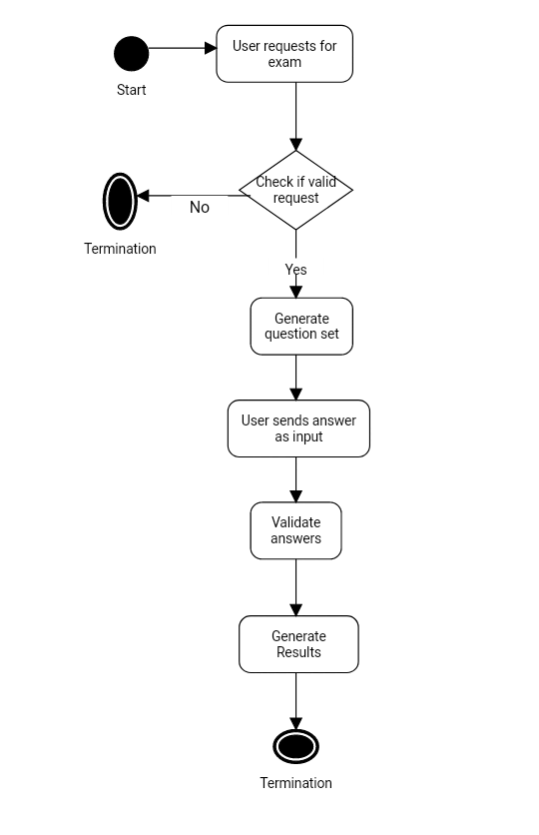

Fig 4.2: Activity Diagram of the System

### 4.1.3. Entity Relationship Schema Diagram

The below is the Entity Relation Diagram with some required entity and its attributes for the system design such as details of the user (student) and their information, designs details and so on. It also reflects the details of the admin, questions and subjects involved in the examination process.

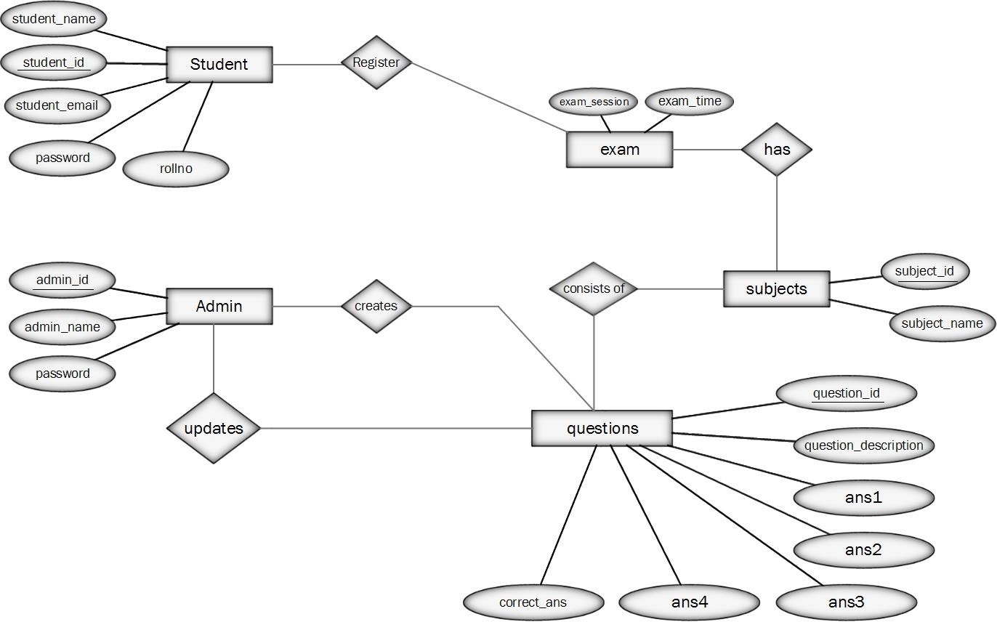

Fig 4.3: Entity Relationship Diagram of the System

## 4.2. The Unified Modeling

### 4.2.1. Sequence diagram

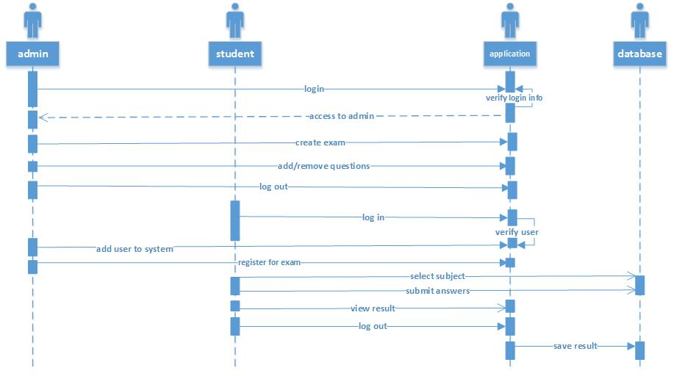

Fig 4.4: Sequence Diagram of the System

In the above sequence diagram the system defines in which manner the system is operating. The student logins and registers to the system application. The application verifies user and thus user can select the subject and submit answers. The student can view result from system which is stored in database. The admin is responsible for adding and modifying the questions and subjects as well as manage the exam credentials like exam time, no. of questions etc.

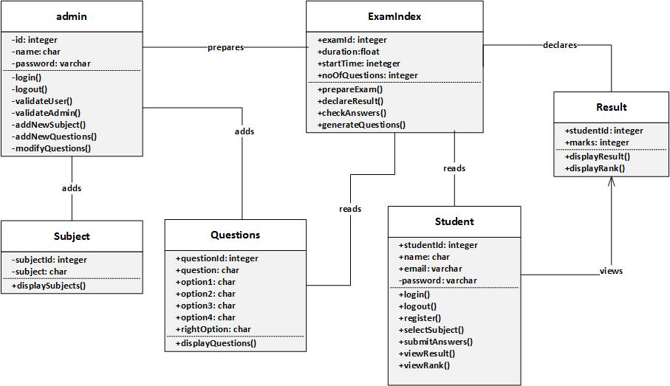

### 4.2.2. Class Diagram

Fig 4.5: Class Diagram of the System

A class diagram models the static structure of a system. It shows relationships between classes, objects, attributes, and operations. In the above class diagram there are six classes each associated with each other. The admin class validates the user and admin login information and also can add or modify the subjects and questions. The exam index is responsible for all exam credentials such as preparing exam, generating questions and checking the answers as well as preparing results.

The student can login or logoutfrom system and select the subject and give exam by submitting the answers. The student also can view the result and rank directly.

The other classes subject and questions contain the information of subjects and questions in the database respectively. The result class displays the result and rank of student.

# Chapter 5: System development and Testing

System development and testing is the most important in SDLC. This stage consists of two most important parts, i.e. coding tools used and testing strategies.

## 5.1. Programming Review

We have used various tools throughout the project. For Front end design, for diagrammatic representation of database schemas, flow diagrams, Activity diagrams, for documentation purposes etc.

### 5.1.1. Front **End**

* HTML (Hyper Text Markup Language) is used to define how the web application looks like. In this system to present whole information to the browser is done with the help of HTML.
* CSS (Cascading Style Sheets) is used in our system to give style to webpages. Various changes in the design of webpages were achieved easily by adding CSS code.
* Bootstrap  
  In this system, Bootstrap is used for designing responsive pages and designing forms.
* JavaScript

JavaScript is used for form validation processes

### 5.1.2. Back End

* MY-SQL

We used MySQL for making database queries. Various operations like insertion, update, deletion etc. in database are carried out with the help of this query language.

* PHP

We have used PHP to develop the overall working of our system.

### 5.1.3. Documentation tools

* MS Word

Microsoft Word is word processor tool. In this project MS word is used for the purpose of documentation.

### 5.1.4. Designing

* Adobe Photoshop CS6

Photoshop is used to build the logo and other icons of the online examination system.

* MS Visio Professional 2013

MS Visio is used for making different diagrams like Use-Case diagram, activity diagrams, ER-diagrams, sequence diagrams etc.

### 5.1.5. Coding tools

* Sublime Editor

Sublime editor is the text editor used for coding purpose.

## 5.2. Algorithm Implementation

### 5.2.1. Fisher Yates Algorithm

1. Write down the numbers from 1 through N.
2. Pick a random number k between one and the number of unstruck numbers remaining (inclusive). The random number k is selected as, k=rand(1 to N)
3. Counting from the low end, strike out the kth number not yet struck out, and write it down at the end of a separate list. (For Modern-Shuffling algorithm to reduce complexities, we place already stroked numbers at the end of the list by swapping them with the last unstruck number at each iteration)

From i=0 to j

Select and swap jth element a[j] to temporary variable as well as a[n] and a[n] is placed at a[j] and N is set to N-1.

1. Repeat from step 2 until all the numbers have been struck out.
2. The sequence of numbers written down in step 3 is now a random permutation of the original numbers.

### 5.2.2. Tokenization Process

1. Get Input answer in Phrase and store in string

Answer_in_phrase_from=String answers

1. Remove special characters like comma, full stops etc.

Preg_replace(/,”’-/) with space

1. Get all the uppercase letters to small case.

answer=string_to_lowercase(answer)

1. Create token of words by detecting white space

answer=explode (" ", answer)

1. Remove stop words like preposition, adverbs, pronouns etc.
2. Select a word for stemming
3. Use Stemming method for removing suffixes.
4. Repeat step 6. until all words are stemmed.
5. Compare tokenized words with answer stored in database
6. Generate result

The pseudo-code for tokenization is:

Answer_in_phrase _from=String answers

Preg_replace(/,”’-/) with space

answer=string_to_lowercase(answer)

definestopwords = array _of_Stopwords[list_of_stopwords]

no_of_stop_words=count(stopwords)

replace special characters with space

answer_length=string_word_count_for(answer)

array_of_answer_words=explode(" ", answer)

from i=0 to answer_length

from j=0 to no_of_stop_words

if(answer_word is not in stop words)

ans=answer[i]

Thus generated token is then passed through function for stemming.

stem = PorterStemmer::Stem(ans)

## 5.3. Testing

Testing is the process of determining whether the developed system meets our objectives or not. It is one of the most important phases of SDLC. This phase consumes 40-50% of development efforts and consumes more effort for systems that require higher levels of reliability. As the amount of maintenance and upgrade of existing systems grow, significant amount of testing will also be needed to verify systems after changes are made. Despite advances in formal methods and verification techniques, a system still needs to be tested before it is used. Testing remains the truly effective means to assure the quality of a software system of nontrivial complexity, as well as one of the most intricate and least understood areas in software engineering. Testing, an important research area within computer science is likely to become even more important in the future.

The various testing techniques used in our online examination system.

Testing is involved in every stage of SDLC, but the testing done at each level of software development is different in nature and has different objectives.

### 5.3.1. Unit Testing

The basic unit of software that is testable is known as a module or unit. After the coding of modules, they were tested, made error free and debugged. In this way we carried out the unit test.

|  |  |  |  |  |
| --- | --- | --- | --- | --- |
| **Test Case Id** | **Test case** | **Steps to be executed** | **Expected result** | **Observed result** |
| 1 | Test if user login succeeds with correct username and correct password | a.Enter correct username and correct password in  respective fields  b.Click Login button | User must be able to login successfully | User logged in successfully |
| 2. | Test if unregistered user is denied  successful login | a.Enter incorrect username and incorrect password in respective fields  b.Click Login button | User must be denied successful login | User could not login |
| 3. | Test if login is denied when username is correct and password filed is empty | a. Enter correct username in  respective field  b. Click Login button | User must be denied successful login | User could not login |
| 4. | Test if user login succeeds with correct username and correct password | a. Enter correct username and correct password in respective fields  b. Click Login button | User must be able to login successfully | User logged in successfully |
| 5. | Test if unregistered user is denied  successful login | a. Enter incorrect username and incorrect password in respective fields  b. Click Login button | User must be denied successful login | User could not login |
| 6. | Test if login is denied when username is correct and password | a. Enter correct username in respective field | User must be denied successful | User could not login |

Table 5.1: Unit Testing

### 5.3.2. Integration Testing

Integration testing is a technique for constructing the program structures, while conducting test to find out errors associated with interfacing, the objective is to take unit tested modules and build a program structure according to design.

It is performed when two or more tested units are combined into a larger structure. The test is often done on both the interfaces between the components and the larger structure being constructed, if its quality property cannot be assessed from its components. After integrating the requirements we tested, it was fine and satisfactory.

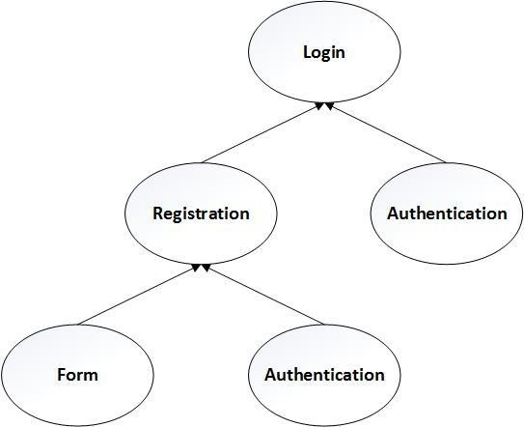

Figure 5.2 (a) - Integration Testing (User Login)

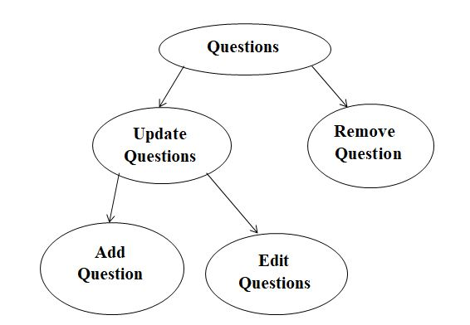

Figure 5.2 (b) - Integration Testing (Question Record Update)

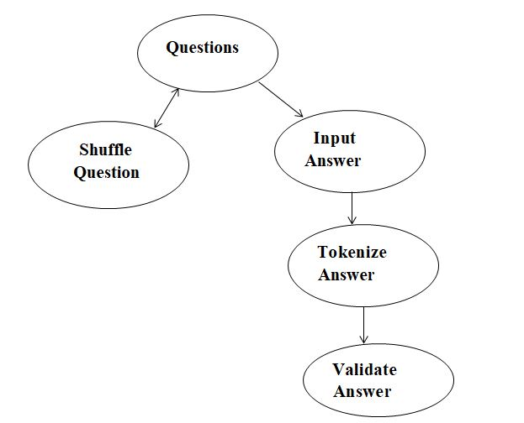

Figure 5.2 (c) - Integration Testing (Question Generation and Answer Validation)

### 5.3.3. System Testing

System testing of software or hardware is testing conducted on a complete, integrated system to evaluate the system’s compliance with its specified requirements. After the working modules were integrated to form a complete system, it was tested again. The completed system fulfilled the specified requirements and works as per desired.

**Test Input:** A whole integrated system

**Processing:** Combination of individual units and testing

**Test Output:** A tested system without errors

## 5.4. Module Description

Well-structured designs improve the maintainability of a system. A structured system is one that is developed from the top down and modular that is broken down into manageable components. In this project we modularized the system so that they have minimal effect on each other.

This application is designed into four independent modules which take care of different tasks efficiently.

1. User Interface Module
2. Admin Module
3. User Module
4. Database Operations Module

### 5.4.1. User Interface Module

In this application we are providing one user interface for accessing this system. The user interface designed completely based on the end users. It provides friendly accessing to the users. This user interface has attractive look and feel.

**Admin Module**

|  |  |  |
| --- | --- | --- |
| Admin credentials | Elaboration | Further Elaboration |
| Create user account | Assign new user id & password for user. |  |
| Delete user account | Administrator can delete the user id & password of unwanted user. |  |
| Modify details | First the details of users are to be obtained by using user id & password or simply checking user database. | After obtaining the original details the updated details are submitted. |
| Add , delete and change questions | On the admin side, using the edit, delete and add option ,admin can perform insert, delete and update operation on questions. |  |

Table 5.1(a): Admin Module

**Client Module**

| User requirements | Elaboration | Further Elaboration |
| --- | --- | --- |
| Login | User enter home page and then login to exam page by entering id & password. |  |
| Adding details | Personal details of user store in to database | Information or designs about the heritages that they want to post. |
|  |  |  |
| Logout | Logout in to the home page |  |

Table 5.1(b): Client Module

### 5.4.2. Database Operations Module

**User Management Module:** The user management module is helpful in adding the details of the users. Also module is used to delete and edit the details.

**Info Management Module:** This module is useful to manage already posted information. Admin can view, public, un-public, edit, or delete the details about the information collected from users.

**Question Management Module:** Question management module is useful to manage the question page of proposed application. Using this module, admin can upload the questions and also possible to edit information about questions and delete the already uploaded questions.

# Chapter 6: Conclusion and Future Enhancements

# 6.1. Conclusion

Online Examination System can be used for taking examinations online via internet. Many users can register to the system and participate in the exams. The system provides two types of exams, one is multiple choice questions and other is word questions. After user gives exam he/she can view their scores. This application is useful for taking exams or practicing for various exams. Hence the use of Fisher Yates and tokenization algorithm has been successful in the development of this project.

# 6.2. Future Enhancement

This system can be enhanced in the future. The web application can be hosted for purpose of using it though internet. The subjects can be added for covering broader areas of study. Users will also be allowed to submit their new ideas and interest of study. The bugs and error in the system will also be minimized and removed. Performance of the webpage will be improved.

# References

[1] The Porter Stemmer home page (with the original paper and code): <http://www.tartarus.org/~martin/PorterStemmer/>

[2]The original paper: Porter, M.F., 1980, An algorithm for suffix stripping, Program, 14(3) P:130-137.

[3]Software Requirements Specification for Problem Based Learning Module, SoumanMandal, 2010

[4] Donald Knuth, “*Art of Computer Programming”*, Algorithm P, Ed-Addison-Wesley, 1962, Volume I

[5] Ian Sommerville,In:Software processes. Ed-Michael Hirsch,”*SoftwareEnggineering”*, 9th Edition Pearson Education, Inc. 2011. P.29-32